Dress for Success!
You will want the organizations to see you as a potential employee not as a student. First impressions count and dressing for success is a key visual that you are a professional.
Please visit the following videos for advice: Vault Advice and The Ladders.com on CNN

Some examples of dressing for success:
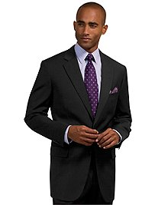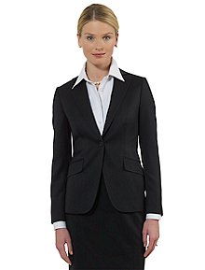
Do’s | Don’ts
Consider the fit of your clothing  Select neutral colors  Keep hair neat, beard shaved and nails well-manicured  Make sure shoes are polished and unscuffed  Maintain good posture and eye contact | Wear something too tight, too baggy, too short or too low-cut  Select jeans or shorts  Wear anything too bright or distracting  Use heavy fragrances  Forget to smile!

EdConnect Gallery:
