CHINA

Higher Education

Pre-university and Post- secondary studies
The Ministry of Education reports that by July 2014, there were 2,542 colleges and universities in China, including 296 adult education higher institutions but excluding independent colleges. Higher education and higher learning in China has the highest growth rate of about 25% increases each year in students and researchers.
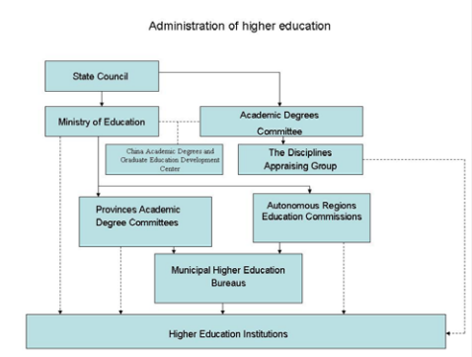

Private higher education institutions are among the fastest growing sector of education in China. Since the 1980s when they were established, they have grown dramatically, some of their programs are run through partnering with foreign universities and colleges. These private institutions charge tuition fees, and they offer two types of programs that lead to a degree recognized by the Ministry of Education. Institutions authorized to provide degrees recognized by the Ministry are listed on the website: http://www.moe.edu.cn/publicfiles/business/htmlfiles/moe/moe_2812/201409/175222.html

Admission is dependent on scores obtained in the national university entrance exam. The curriculum and guidelines are nationally prepared and the number of students placed in specific programs and specific institutions is based on economic needs projected by central governmental planning. Upon completion on these programs, graduates and appointed employment by the government. This system is changing with the popularity of private higher education institutions.
Specialized Institutions
These institutions offer degree programs in Agriculture, Medicine and Pharmacy, Arts, Natural Science, Engineering, Physical Culture, Finance and Economics, Political Science and Law, Forestry, Teacher Training and Humanities.
Junior Colleges
Offer programs which represent less than four years of full time study in agriculture, animal husbandry, commerce, engineering and technology, medical sciences, navigation, sericulture, teacher training and tourism. Admission to these colleges are usually based on graduation from senior middle school and scores on the national university entrance exams. Diplomas are earned upon completion or two or three year full time programs, or three to four year part time programs. Upon completion, successful students may apply to the third year of a Bachelor’s degree program in a degree granting higher education institution.
Vocational Universities
These are part of the formal system of higher education. They address the manpower requirements of the community in which they are located. Some of the institutions have grown out of employees’ colleges and other from branch colleges of large universities. Graduates gain diplomas but very few can grant Bachelor’s degrees.
Adult (non-formal) Higher Education
The Adult Education Guidance and Coordination Commission under the State Education commission of 1986 is in charge of adult higher education. Mostly admission is based on the national entrance exam for higher education, which differed from the mainstream college entrance exam. Adult education though considered higher education, is considered lower than the formal programs of higher education.

Getting hired by a university will likely involve a test and an interview process. Most universities post opportunities directly on their websites. In China, networking is crucial and more nuances, and sometimes more effective in person. Some find it easier to be in China to meet in person with people in order to more effectively network. This is tricky if you are not Chinese.

