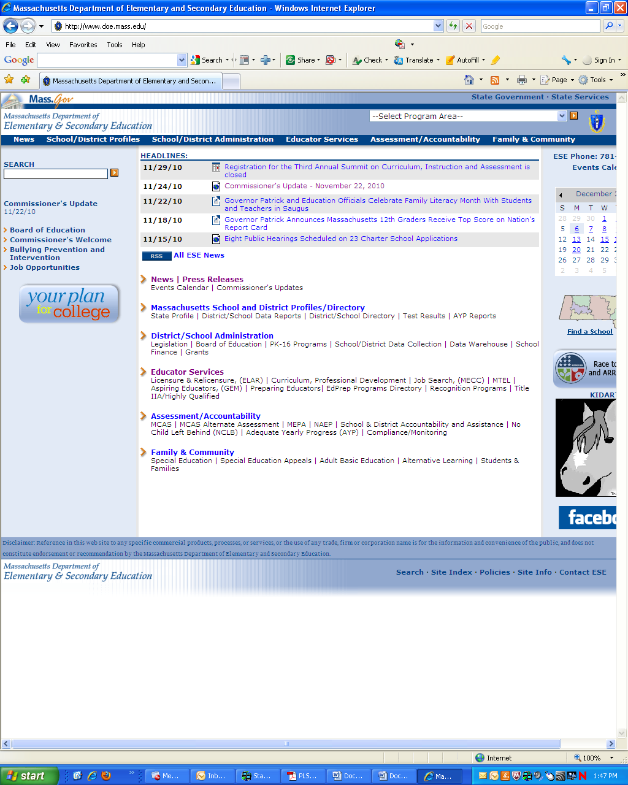
MA DESE Web Site
Click on Educator Services
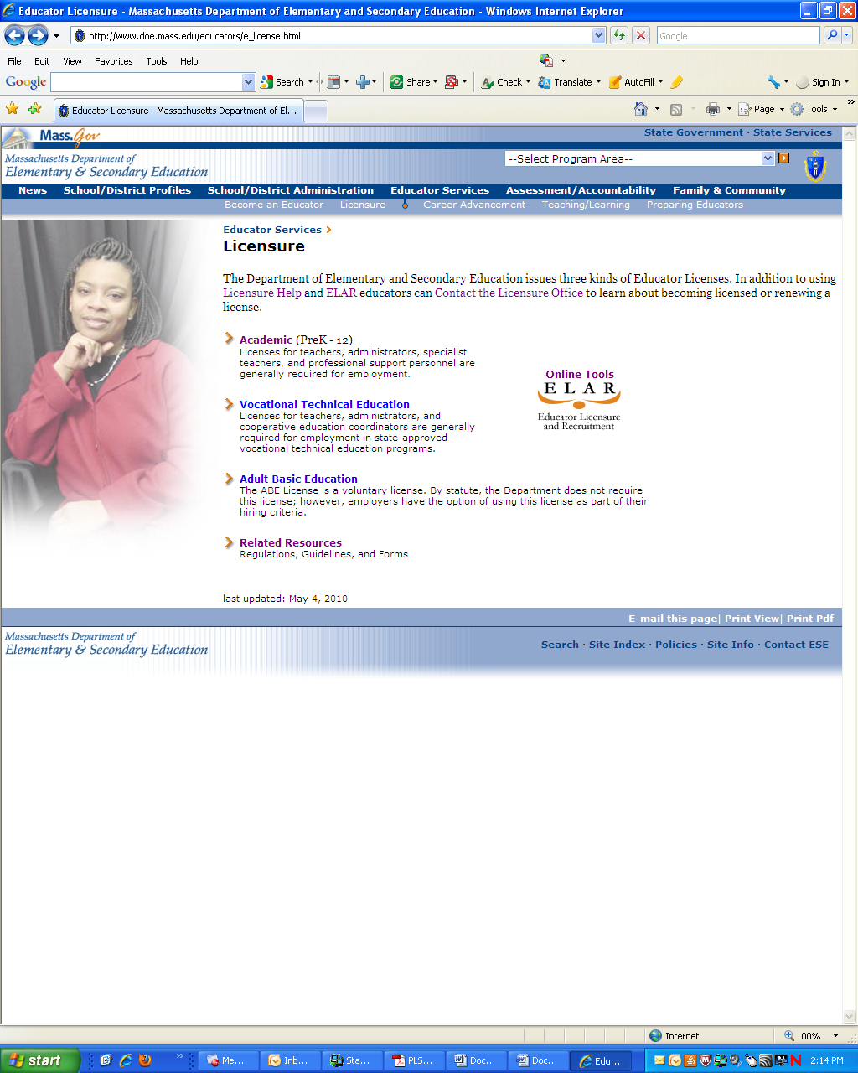
You can Click on Academic (then Apply Online) or OR
CLICK on ELAR to begin
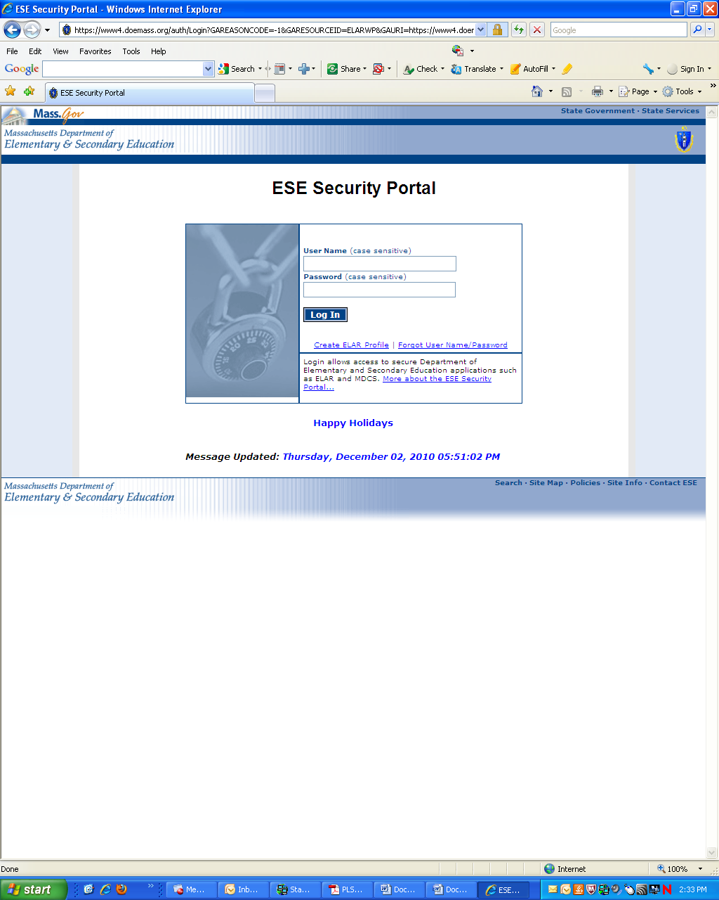
Click on Create ELAR Profile to create username and password. You will submit personal information to create your profile. Log In here if you already have a profile.
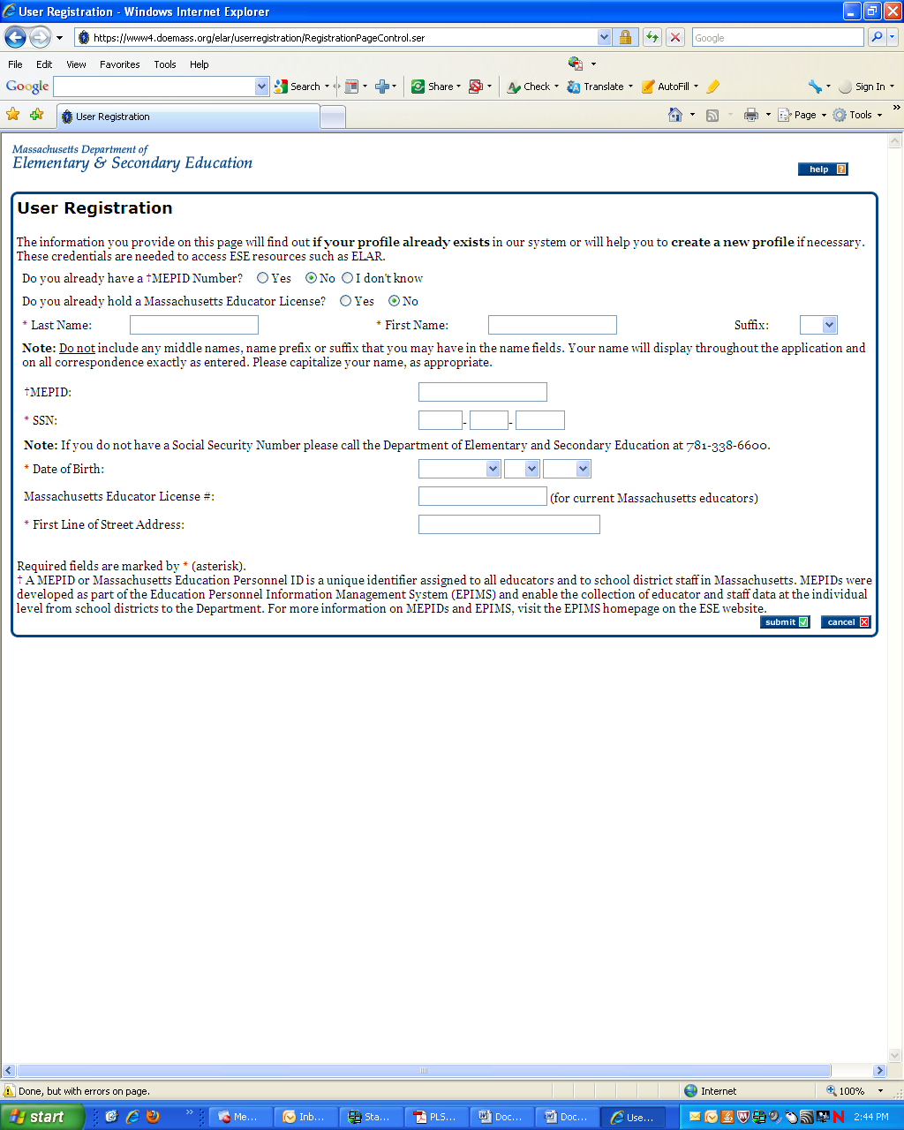
For new users, this is the first page of creating your ELAR profile. You will not have a MEPID number if this is your first time here.
Once back on ELAR, the system will provide you a menu of options-one of them prompting you to Apply for Licensure.
After you hit the submit button, you will get instructions on completing your profile, followed by a registration processing message from ELAR. Finally, you will be issued a username and password (you can change password later) that you will then use to sign in to ELAR.
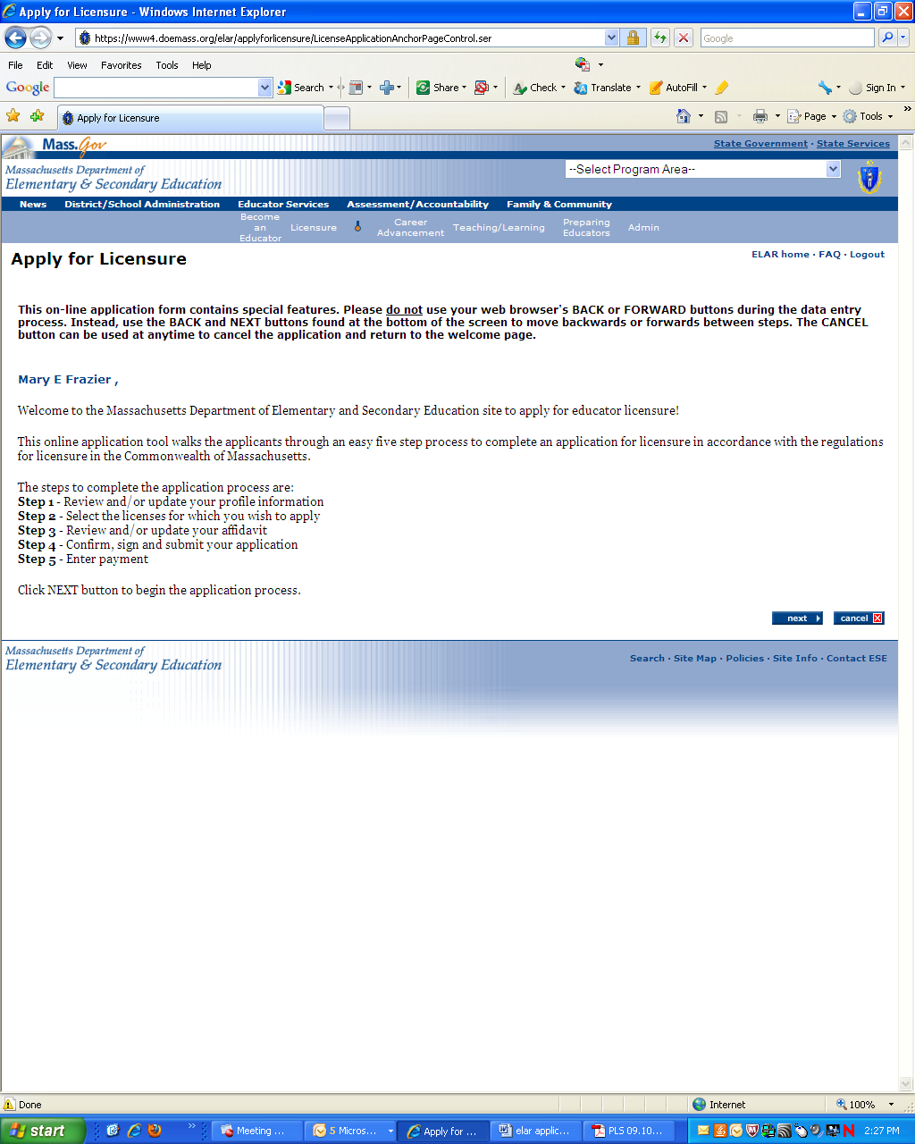
Does it have to have a MA address? NO. Licenses on online and only sent to you per your request.
This first step will allow you to edit parts of your profile or you can click the next button to advance to applying for licenses.
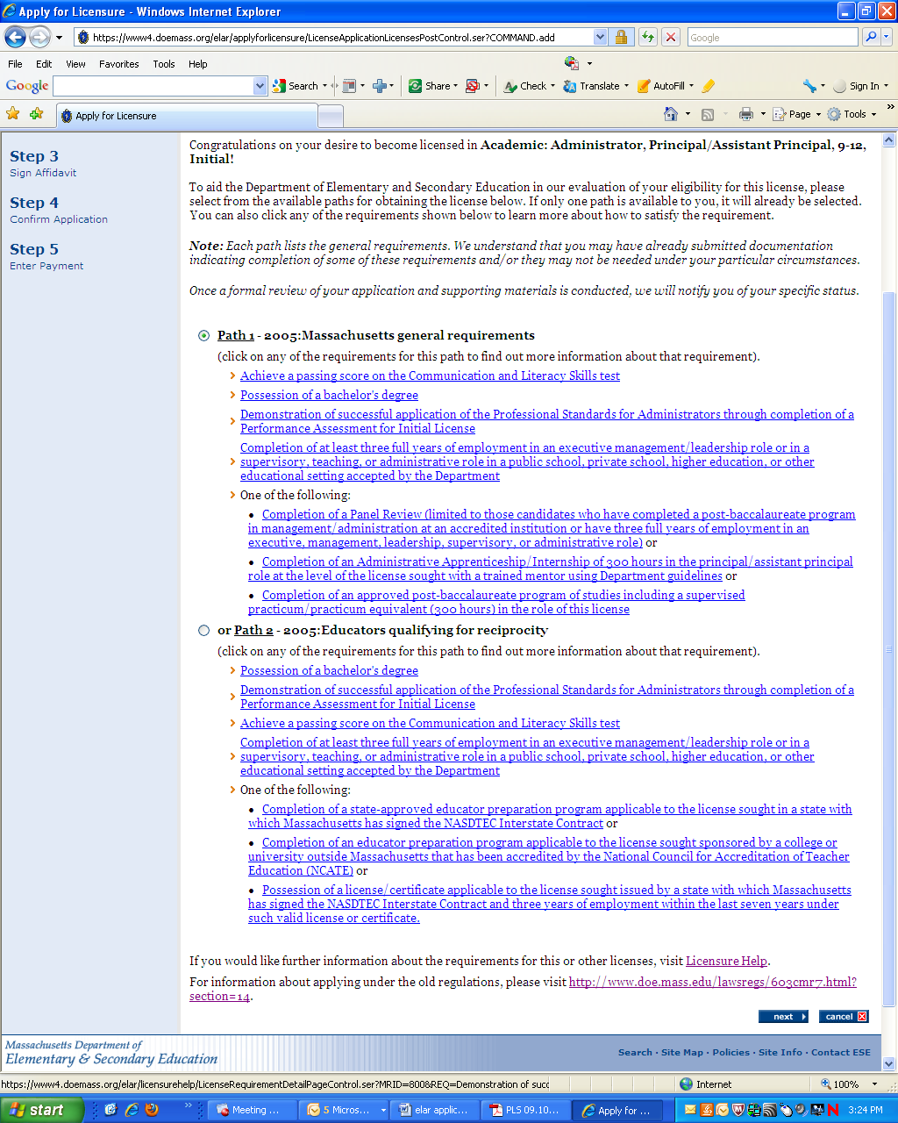
The system is supposed to default to correct pathway.
Click next whether or not you plan to add another license.
If you plan to add another license, you will be prompted to do so. Otherwise, click next when you are done.

On the following page, select “Endorsements” from the drop down list and then select the appropriate endorsement “Sheltered English Immersion – Administrator.” Select the “Level” and “Type” and then click “add”.
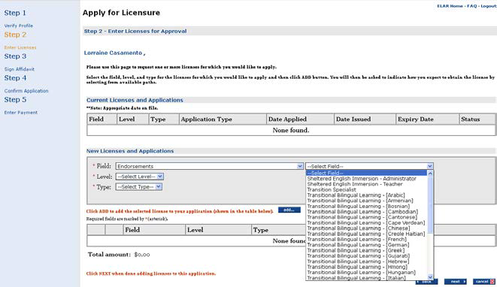

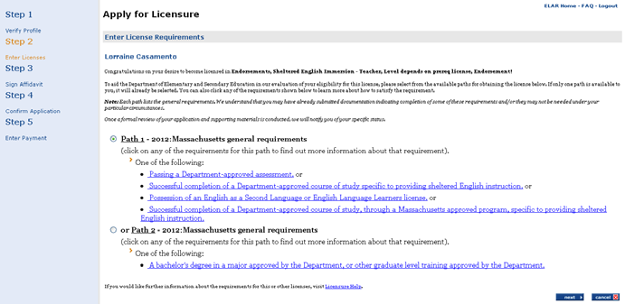
Select the path to earn the endorsement and click “next”. For Administrators there is Path 1.
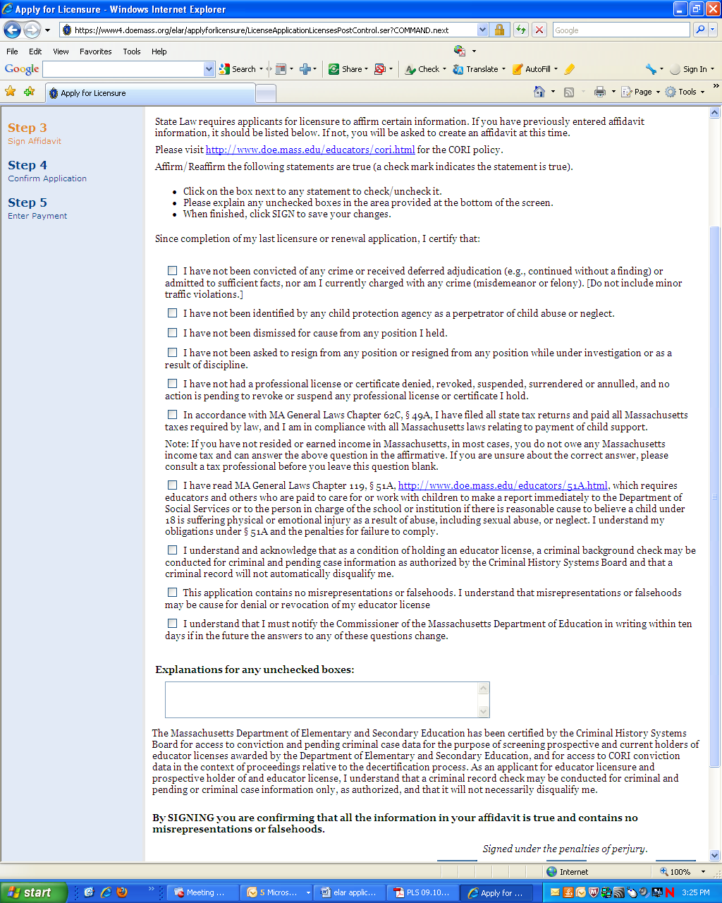
You MUST click and read this law or your license might not process.
A confirmation box will pop up when you ”sign” affidavit.
All boxes must be checked or an explanation given.
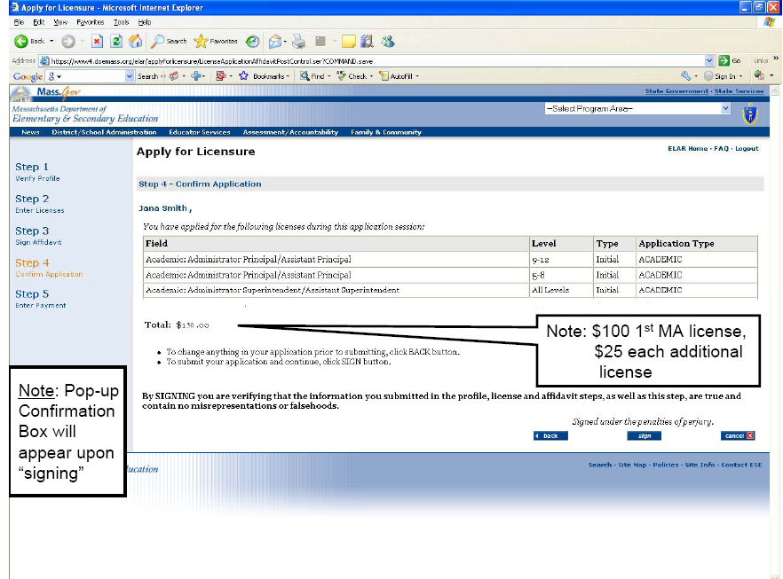
After signing, you will be sent to a secure portal where you can pay online with a credit card. This is the fastest process. SAVE A PRINTOUT OF YOUR PAYMENT RECEIPT.
After affidavit is signed you will go to confirmation page.

You will get an automated message from DESE regarding your application. HGSE LICENSURE WILL BE SUBMITTING YOUR DOCUMENTS TO DESE SO WHEN YOU GET AN EMAIL NOTICE FROM DESE REQUESTING DOCUMENTATION, REMEMBER THAT LICENSURE HANDLES THIS AS PART OF OUR SERVICES ASSISTING YOU TO GET YOUR MA LICENSE. This means you have one less must-do item!

