Prioritizing Sections in Your Profile:
The Summary should always come first. This will drive the reader to explore your profile.
If you are leveraging your prior professional experience to return to an employer or move up in your current sector & role, then Experience should come next.
If you are changing careers, you should use Projects to detail relevant course projects and internships that are relevant.
Education should come after Experience & Projects. It should include all universities and colleges attended to allow connections with alumni.
Certifications should come after education and include any relevant certifications to your desired jobs.
Languages and Publications may be used based on your career goals. Location of these sections will vary based on their importance.
Recommendations are written specifically for you and should support your strengths. They will show under the experience therefore are not moveable and are at the bottom. These are preferred over Endorsements.
Skills should go towards bottom. These are searchable; however, should not be the primary focus.
Additional Organizations should support your career interests and be towards the bottom.
Connections, Groups and Following are at the bottom and should support your career goals.

The Job Seeker’s LinkedIn Profile
The Profile
LinkedIn is an important tool to optimize your opportunities in a job search. This stands as an introduction to potential networks in your profession, so you will need to consider each section carefully.
- The Header: Name, Tag, Geography, & Industry
- Summary
- Experience and Projects
- Education
- Skills, Endorsements & Recommendations
- Additional Information

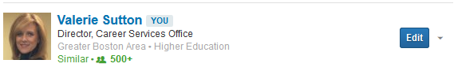

The Header
The Profile Header is the first thing hiring managers see in an advanced search of candidates, so make it count.
- Name: Use the one that will make it easiest for people to find you. Include your maiden name, if you have just married.
- Tagline: Do not put job seeker, student or looking for opportunities. Use your current title or career aspiration (e.g., Professional Educator focused on Diversity & Inclusion or Career Development Specialist).
- Geography: Put the location you want to live, if different from your current location.
- Industry: This is searchable, so you will want to pick the industry that most closely matches your organizations of interest.
- Picture: Upload a professional headshot. Set your picture privacy settings for first degree connections only. This will help to avoid unintentional bias.

The Summary:
The summary is a brief narrative about where you want to focus your attention professionally – keeping it focused but broad enough to fit multiple sectors and roles.
The first statement should be your mission alignment as it relates to your career goals. This should focus on the questions that drive you (e.g., teacher quality, leadership development, immigration issues). Write a statement of your mission alignment in 100 words or less here:
________________________________________________________________________________________________
________________________________________________________________________________________________
The second statement focuses on your strengths – the skills and qualifications that you want to use in your career (e.g. measurement & evaluation, developing programs, managing staff). Write a statement focused on your strengths in 150 words or less here:
________________________________________________________________________________________________
________________________________________________________________________________________________
________________________________________________________________________________________________

Projects Section
- Use this section instead of Courses or Volunteering & Causes. It will allow you to showcase your experience and avoid bias.
- Treat similarly to Experience section. Focus the description focused on keywords, scope, and achievement.
- Only add people to the project who will speak well of you.
- Order your projects based on their relevance to the job you seek.

Experience Section
- Choose relevant experience not only based on your career goals, as well as, the network that can be created.
- Focus the description on the scope and achievement of your work. Use numbers and include your awards or honors for each job you list.
- Be sure to include the proper key words for searches.
- Remember to be concise! Readers tend to skim profiles.
- Make sure your profile is consistent with your resume.

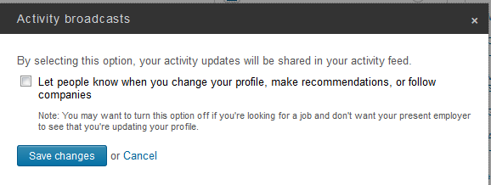
Be sure to turn off your activity broadcast and review all of your privacy settings!

